DAY-15
Task-01
What is angular? Explain briefly.
Angular is an open-source, TypeScript-based front-end framework developed by Google. It is used to build dynamic, single-page web applications (SPAs). Angular uses a component-based architecture and provides features such as two-way data binding, dependency injection, routing, and reusable components, making web applications scalable, maintainable, and efficient.

Task-02
What is data binding? Explain.
How many types of data bindings do you have .. can you explain them.

Data Binding is the process of connecting a component's data with the HTML view in Angular. It enables communication between the component and the UI. Angular provides four types of data binding:

Interpolation ({{ }}) – Displays data from the component to the view.
Property Binding ([ ]) – Binds component properties to HTML element properties.
Event Binding (( )) – Handles user events and sends actions from the view to the component.
Two-Way Data Binding ([(ngModel)]) – Synchronizes data between the component and the view in both directions

Task-03
Why do you need Angular? Can you give some advantages of using angular with description.
We need Angular to build modern, dynamic, fast, and scalable web applications. It provides a complete framework with built-in features such as routing, forms, dependency injection, data binding, and state management, making development easier and more organized.
Angular is especially useful for developing Single Page Applications (SPAs) where users can navigate between pages without reloading the entire website.
Advantage | Description
Component-Based Architecture | Reusable and maintainable code using components.
Two-Way Data Binding | Automatically synchronizes data between UI and component.
Dependency Injection | Makes applications modular, reusable, and easier to test.
Routing | Enables navigation without reloading the page.
TypeScript Support | Provides strong typing and better code quality.
High Performance | Faster execution with optimized rendering and compilation.
Testing Support | Easy unit and end-to-end testing.
Cross-Platform | Build web, mobile, desktop, and PWA applications.
Community Support | Backed by Google with extensive documentation.
Security | Built-in protection against common web security threats.

Task 4: What is REST API?
REST API (Representational State Transfer Application Programming Interface) is a set of rules that allows different software applications to communicate with each other over the internet using the HTTP protocol.
A REST API enables the frontend (Angular, React, etc.) to communicate with the backend (Java, Spring Boot, Node.js, etc.) by sending HTTP requests and receiving responses, usually in JSON format.

Task 5: Why do we use REST API?
We use REST APIs because they provide a standard way for different applications to communicate.
Advantages
1. Communication Between Frontend and Backend
Angular communicates with backend applications through REST APIs.
2. Platform Independent
The frontend and backend can be built using different technologies.
Example:
- Frontend → Angular
- Backend → Spring Boot
- Database → PostgreSQL
3. Lightweight
REST commonly uses JSON, which is smaller and faster than XML.
4. Scalable
REST APIs are suitable for large enterprise applications.
5. Stateless
Each request contains all the information needed, making applications easier to scale.

Task 6:
What are single Page Applications?
A Single Page Application (SPA) is a web application that loads only one HTML page initially. After that, only the required content is updated dynamically without refreshing the entire page.
Angular is designed to build SPAs.
Traditional Website
User clicks Page 1
↓
Server sends new HTML page

User clicks Page 2
↓
Server sends another HTML page
Every page navigation reloads the browser.

Single Page Application (SPA)
User opens website
↓
One HTML page loads

User clicks Dashboard
↓
Only Dashboard content updates

User clicks Profile
↓
Only Profile content updates
No full page reload occurs.
Advantages of SPAs
- Faster navigation
- Better user experience
- Reduced server load
- Dynamic content updates
- Less bandwidth usage
Examples
- Gmail
- Google Maps
- Facebook
- Netflix
- Angular applications

Task-07
Explain modules, components and services in Angular.

Feature |  | Module | Component | Service
Purpose |  | Organizes the application | Builds the user interface | Contains reusable business logic
Contains |  | Components, services, directives | HTML, CSS, TypeScript | TypeScript methods and logic
Reusable |  | Yes | Yes | Yes
Example |  | AppModule | HomeComponent | EmployeeService

Task 2 & Task8 are same
Task-09
What Are decorators? Explain types of decorators
Decorators tell Angular how a class, property, method, or parameter should be used.
Decorators always start with the @ symbol.
Decorator Type | Purpose | Examples
Class Decorator | Defines the role of a class | @Component, @NgModule, @Injectable, @Directive, @Pipe
Property Decorator | Adds behavior to class properties | @Input, @Output, @HostBinding
Method Decorator | Adds behavior to methods | @HostListener
Parameter Decorator | Specifies dependency injection for constructor parameters | @Inject

Task-10
What are Annotations in Angular?
In modern Angular (Angular 2+), the term annotations is commonly used interchangeably with decorators. Technically, Angular uses TypeScript decorators (prefixed with @) to attach metadata to classes and their members.
Task-11

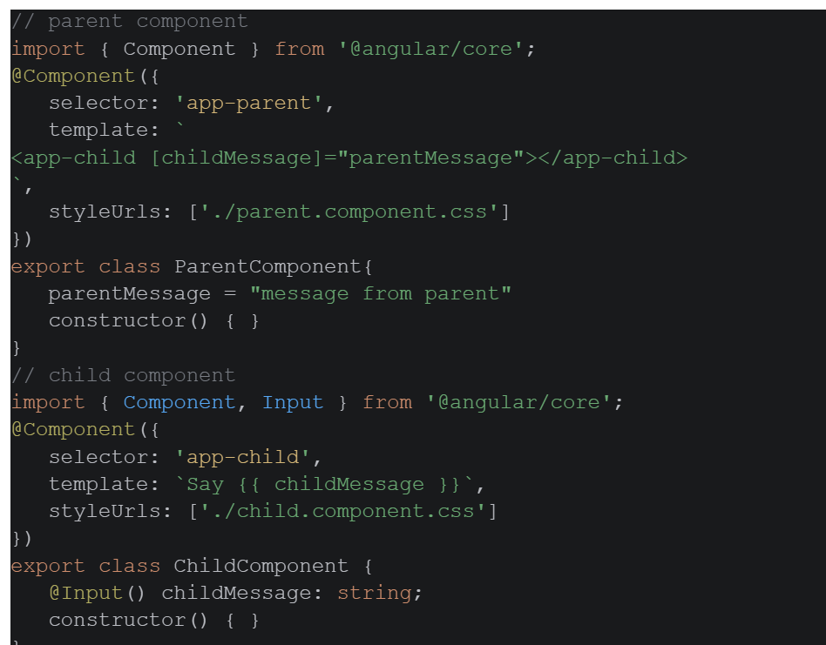

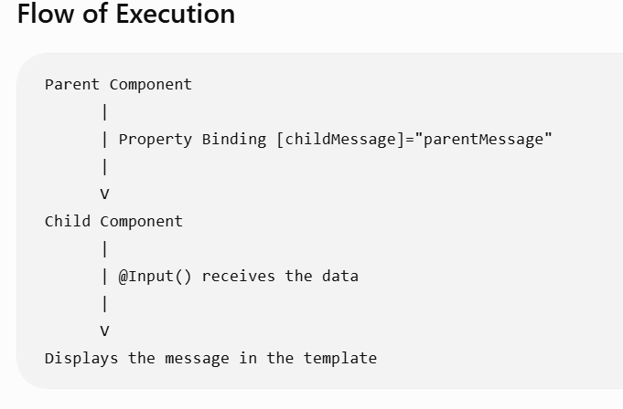

Task-12
Can you create a typescript class with a constructor and a function.

class Employee {
// Properties
id: number;
name: string;
salary: number;
// Constructor
constructor(id: number, name: string, salary: number) {
this.id = id;
this.name = name;
this.salary = salary;
}
// Function
displayDetails(): void {
console.log('Employee ID: ' + this.id);
console.log('Employee Name: ' + this.name);
console.log('Employee Salary: ' + this.salary);
}
}
// Creating an object
let emp = new Employee(101, 'Nagurvali', 50000);
// Calling the function
emp.displayDetails();

Task-13
There is something called eager loading. What do you mean by eager and lazy loading?
Definition
Eager Loading means the related objects are loaded immediately when the parent object is fetched.
Lazy Loading
Definition
Lazy Loading means the related objects are loaded only when they are actually accessed.
In other words:
Only the parent object is loaded initially. The child data is fetched later, when needed.

Task-14

What is an observable response?

In Angular, an Observable is an object provided by the RxJS library that represents a stream of data that can be received over time. It is commonly used to handle asynchronous operations such as HTTP requests, user events, or timers.
When we say Observable Response, we mean that the response from an operation (such as a REST API call) is returned as an Observable, and we receive the data by subscribing to it.
Task-15
What is the flow of your Angular project.. Explain with an ex.
User
|
v
index.html
|
v
main.ts
|
v
AppComponent (Root Component)
|
v
App Template (HTML)
|
v
User Action (Click/Button/Form)
|
v
Component (TypeScript)
|
v
Service
|
v
HTTP Client
|
v
REST API (Spring Boot/Node.js)
|
v
Database
|
v
REST API Response (JSON)
|
v
Service
|
v
Component
|
v
HTML Template (View Updated)

<!doctype html>
<html lang="en">
<head>
<meta charset="utf-8">
<title>Shaik</title>
<p>Welcome to Angular</p>
<base href="/">
<meta name="viewport" content="width=device-width, initial-scale=1">
<link rel="icon" type="image/x-icon" href="favicon.ico">
</head>
<body>
<app-root></app-root>
</body>
</html>

body{
font-family: Arial;
}
h1{
text-align:center;
color:blue;
}

import { bootstrapApplication } from '@angular/platform-browser';
import { appConfig } from './app/app.config';
import { App } from './app/app';
bootstrapApplication(App, appConfig)
.catch((err) => console.error(err));

import { ApplicationConfig, provideBrowserGlobalErrorListeners } from '@angular/core';
import { provideRouter } from '@angular/router';
import { routes } from './app.routes';
import { provideClientHydration } from '@angular/platform-browser';
export const appConfig: ApplicationConfig = {
providers: [
provideBrowserGlobalErrorListeners(),
provideRouter(routes), provideClientHydration()
]
};

import { Routes } from '@angular/router';
import { DashboardComponent } from './dashboard.component';
import { TransactionComponent } from './Transaction.component';
export const routes: Routes = [
{ path: 'dashboard', component: DashboardComponent },
{ path: 'transaction', component: TransactionComponent },
{ path: '', redirectTo: 'dashboard', pathMatch: 'full' },
];

import { Component } from '@angular/core';
import { RouterOutlet, RouterLink } from '@angular/router';
@Component({
selector: 'app-root',
standalone: true,
imports: [RouterOutlet, RouterLink],
templateUrl: './app.html',
styleUrl: './app.css',
})
export class App {
title = 'ABC Bank';
}

import { Component } from '@angular/core';
import { BankService } from './bank.spec';
@Component({
selector: 'app-dashboard',
standalone: true,
templateUrl: './dashboard.component.html',
styleUrl: './dashboard.component.css',
})
export class DashboardComponent {
constructor(public bank: BankService) {}
}

<h2>Transaction Form</h2>
<label>
<input
type="radio"
value="Deposit"
[(ngModel)]="transactionType">
Deposit
</label>
&nbsp;&nbsp;
<label>
<input
type="radio"
value="Withdraw"
[(ngModel)]="transactionType">
Withdraw
</label>
<br><br>
<label>
Amount
</label>
<br>
<input
type="number"
[(ngModel)]="amount"
placeholder="Enter Amount">
<br><br>
<button (click)="submitTransaction()">
Submit
</button>
<hr>
<h2>
Transaction History
</h2>
<table border="1">
<tr>
<th>Date</th>
<th>Type</th>
<th>Amount</th>
</tr>
@for(t of bank.transactions;track t){
<tr>
<td>{{t.date}}</td>
<td>{{t.type}}</td>
<td>{{t.amount}}</td>
</tr>
}
</table>

.card{
width:500px;
padding:20px;
border:1px solid gray;
border-radius:10px;
}
table{
width:100%;
border-collapse:collapse;
}
th,td{
padding:10px;
text-align:center;
}

.dashboard{
width:500px;
margin:auto;
padding:20px;
border:1px solid gray;
border-radius:10px;
}
table{
width:100%;
}
td{
padding:10px;
}

import { Service } from '@angular/core';
@Service()
export class Bank {}

import { Component } from '@angular/core';
import { FormsModule } from '@angular/forms';
import { BankService } from './bank.spec';
@Component({
selector: 'app-transaction',
standalone: true,
imports: [FormsModule],
templateUrl: './transaction.component.html',
styleUrl: './transaction.component.css',
})
export class TransactionComponent {
amount: number = 0;
transactionType: string = 'Deposit';
constructor(public bank: BankService) {}
submitTransaction() {
if (this.transactionType == 'Deposit') {
this.bank.deposit(this.amount);
} else {
this.bank.withdraw(this.amount);
}
this.amount = 0;
}
}

<h1 style="text-align:center;">{{ title }}</h1>
<nav>
<a routerLink="/dashboard">Dashboard</a> |
<a routerLink="/transaction">Transaction</a>
</nav>
<hr>
<router-outlet></router-outlet>

